### GOVERNMENT ARTS COLLEGE,DHARMAPURI636705.

## DEPARTMENT OF ELECTRONICS & COMMUNICAION

#### AFFILIATED TO PERIYAR UNIVERSITY 2023-2024

#### NAAN MUDHALVAN PROJECT REPORT

#### Submitted in Partial Fulfilment of the Requirements for Degree

## of

## B.Sc., ELECTRONICS & COMMUNICATION

## Submitted to

## Periyar University, Salem-636 011

# By

#### GOPIKRISHNAN M

#### AATHILINGAM P

#### SIVANESAN S

#### SARGUNAN M

#### DEEPIKA S

## IREVOLUTION : AN EXPLORATION OF APPLE’S IPHONE IMPACT

## IN INDIA

#### The world has changed as a consequence of the increasing use of smartphones, which have improved communication, connected people, and revolutionized many different businesses. With its main product, the iPhone, capturing markets around the world, Apple Inc. has emerged as a prominent player among the top smartphone makers. India, one of the economies with the greatest economic growth, has seen a tremendous increase in smartphone usage, making it an interesting market to study the effects of Apple's iPhone.

#### In order to shed light on important factors like market penetration, customer preferences, economic ramifications, and societal changes, this research report will perform a datadriven investigation of the impact of the iPhone in India. This study will offer invaluable insights into the transformative impact of the iPhone on India's technological landscape and the lives of its consumers by using advanced data analytics techniques and analyzing large datasets.

#### Apple has a special chance to increase its market share and develop a significant presence in India thanks to the country's large population and rising smartphone adoption. Each new iPhone model unveiling generates excitement and anticipation among Indian buyers. By utilizing the plethora of information Already accessible, this research aims to go beyond conjecture and anecdotal evidence in order to develop a thorough knowledge of the effects of the iPhone.

#### PURPOSE :

#### The technical architecture involves leveraging the data analytics capabilities of Tableau for visualizations and analysis. The architecture comprises several components to ensure efficient data processing and visualization.

#### At the core of the architecture is the data infrastructure, which includes data sources such as market reports, economic indicators, and surveys conducted among iPhone users in India. These data sources are collected and stored in a structured format for further

#### analysis. Tableau is used as the primary data visualization tool. It connects to the data sources and allows for data extraction, transformation, and loading (ETL) processes. Tableau's intuitive interface enables users to create interactive and visually appealing visualizations, charts, and dashboards based on the analyzed data.

## 1.EMPATHY MAP

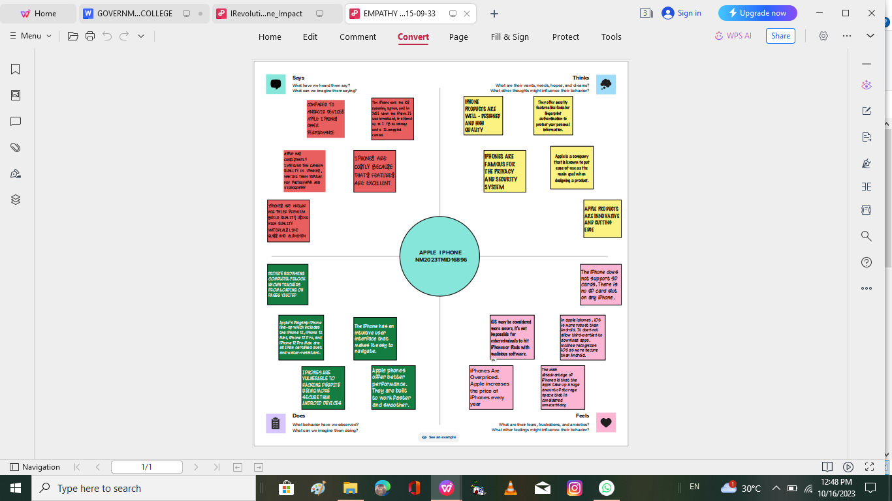

## 2.BRIANSTORM MAP

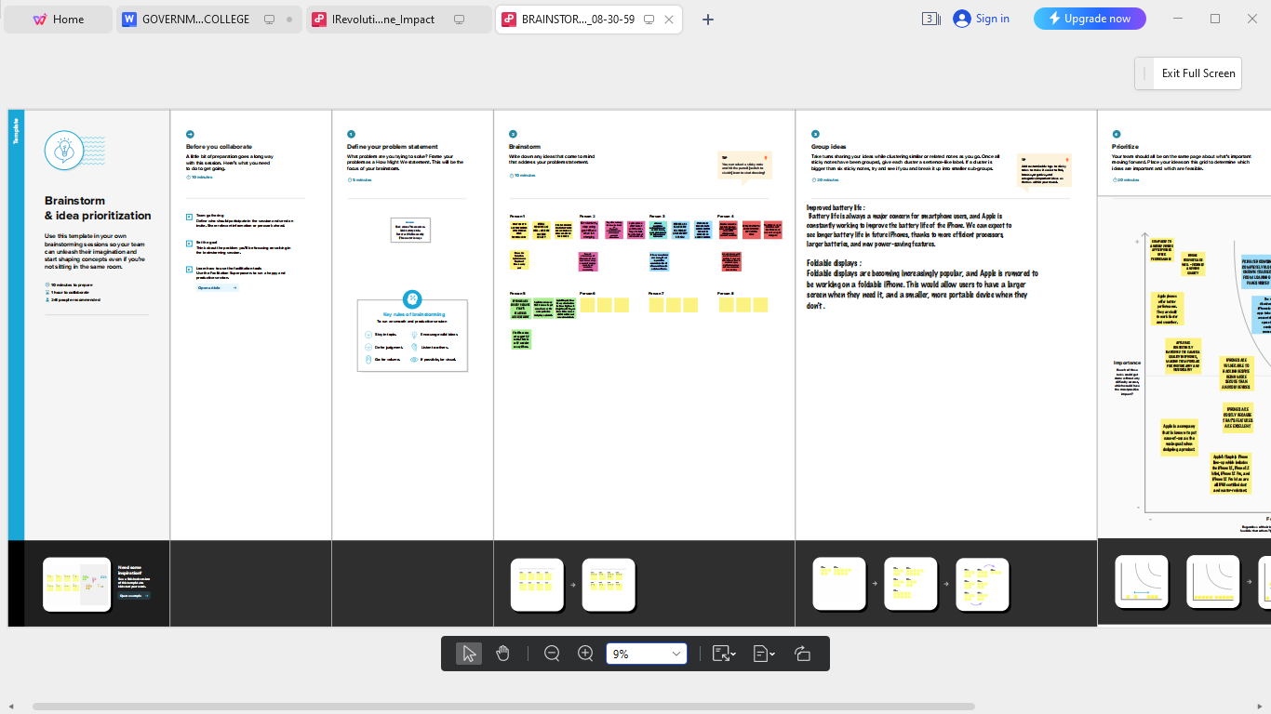

#### RESULT :

FINAL FINDINGS (OUTPUTS ) OF THE PROJECT ALONG WITH SCREEN SHOTS.

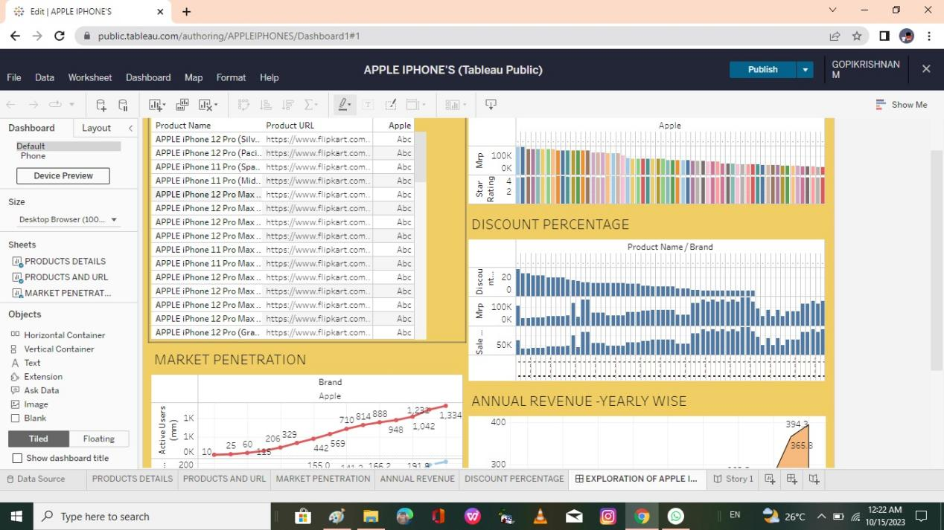

## STORY

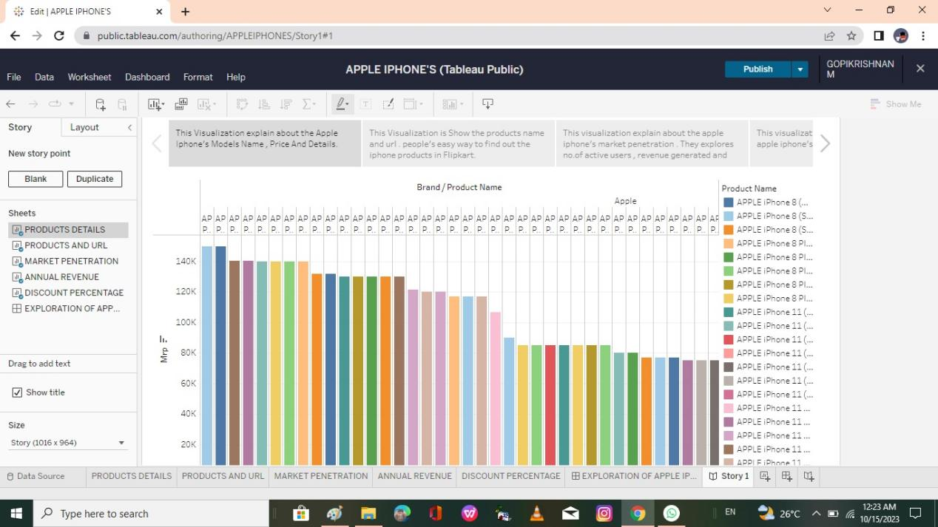

## ADVANTAGES AND DISADVANTAGES

#### 1 Better Performance

#### 2 Easy to Use

#### 3 Timely OS Update

#### 4 Security and Privacy

#### 5 Third-party App Security

#### 6 No Bloatware

#### 7 Family Sharing

#### 8 The Apple Ecosystem

#### 9 Apple CarPlay

#### 10 Retain Value

#### 11 Best Support

#### Bonus: Transfer Data to iPhone Easily

## 1 Better Performance

Compared to Android devices, Apple phones offer better performance. They are built to work faster and smoother. Even the old iPhone models work well and have smooth functioning.

#### With excellent internal storage, iPhones feel like a magical illustration. They have much higher internal storage and do not frequently hang, which keeps them performing flawlessly.

#### Furthermore, Apple is optimized to perform flawlessly with its limited devices. Unlike iPhones, Android devices are optimized via OEM, which sometimes does a poor job.

#### All Apple devices' production is controlled and monitored strictly, resulting in excellent performance designs. Also, the Qualcomm processor of Android is a bit slower than the smooth processor of iPhones.These are some of the reasons that help iPhones have faster and better performance than Android devices.

## 2. Easy to Use

#### Another advantage of the iPhone over Android is the ease of use. The simple interface of the iPhone allows you to easily reach your endpoint destination without getting confused.

## PRIVACY & SECURITY

#### One thing that iPhones are famous for is their privacy and security. It offers a range of security features, including facial recognition and finger authentication.

#### In addition, Apple stops apps from tracking your location and data. iPhones' iMessage and FaceTime video calling features are also end-to-end encrypted.

#### 4.Third-party App Security

#### Before Apple releases any of its devices to the public, it ensures that the devices meet certain quality and security standards. That's why all Apple devices can offer third-party app security to users.

## DISADVANTAGES

#### 1. Cost: The iPhone is one of the most expensive smartphones on the market. High-end models can cost over $1000, which makes it a luxury item for many people.

#### 2. Non-Removable Battery: The iPhone’s batteries are non-removable, which means that users cannot replace them. This can be a disadvantage for people who rely heavily on their phones and have to replace them regularly.

#### 3. Limited Customization: One of the disadvantages of the iPhone is that it has limited customization options. Unlike Android devices, users cannot customize their phone’s interface, which can be a disadvantage for some people.

#### 4. No Expandable Storage: Another disadvantage of the iPhone is that it has no expandable storage options. Users have to purchase iPhones with larger storage capacities, which can be costly.

#### 5. Frailty: The iPhone is known to be fragile and prone to breaking if dropped. Many users have reported cracking or shattering their screens after accidentally dropping their devices.

#### In conclusion, the iPhone has been a game-changer in the technological world. It has revolutionized the way people communicate and access information. However, its advantages and disadvantages must be weighed carefully by potential buyers. Ultimately, the choice of whether to purchase an iPhone depends on the user’s preference, needs, and budget.

## CONCLUSION :

Research must focus on how Apple's iPhone has affected business in India. We seek to examine theeconomic effects of iPhone uptake in the Indian market using data analytics and Tableau visualizations.

#### Examining iPhone sales data, market share, revenue creation, and its **effects on different industries like e-commerce, app development, and** digital payments are all part of this. Organizations can find possibilities for growth and innovation by understanding the business impact and using it to help them position themselves in their markets and make strategic decisions.

## FUTURE SCOPE :

#### Through this program, training modules in coding and robotics will also be provided. In addition, psychological counselors and medical physicians will provide guidance on the student's nutrition, physical fitness, and overall personality development

# THE END